**Different sample division techniques like**

**Coning and Quartering and Riffle sampling techniques &**

**Collection of sample by Riffle sampling technique**

**Theory:**

**Different methods of sample reduction**

For the purpose whenever we collect sample, the initial sample quantity collected is always more than the quantity required. In order to reduce the sample to the required size, the collected sample is thoroughly mixed, dried and reduced to the final sample quantity required using coning & quartering and riffle sampling techniques.

**Coning and Quartering** This method is well suited for large lots of material.

1. It can be conveniently done using shovels, or even front end loaders for very large samples. After thorough mixing, all the material is piled in the form of a radially symmetric cone.

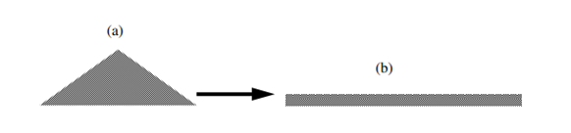

1. The pile is then spread from the center to form a flattened disk of material.

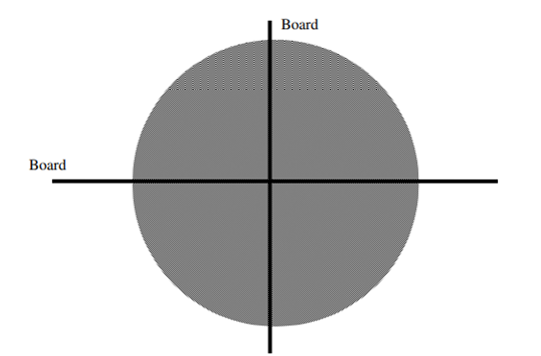

1. The flattened disk of material is then divided into quarters using perpendicular boards.
2. One pair of opposite quarter is removed (rejected) and other pair is combined and used as sample for further division.
3. If the sample is larger than requirement, the process is repeated until suitable size is obtained.

This method of reduction of sample may have human errors.

**Riffle method**

These are often called riffle or chute splitters. These consist of a series of chutes that run in alternating directions, so that when material is poured into the top of the splitter, it flows through chutes and is randomly divided into two equal sized fractions.

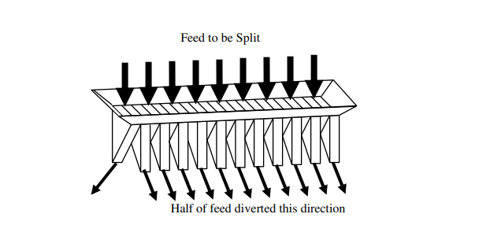

One of the fractions can then be split again, and the procedure can be repeated until a sample of the desired size is obtained. In order to work properly, these splitters must be fed using a special pan that is exactly the same width as the top of the chutes, otherwise the amount of material entering the two end chutes will be different and the sample will be incorrect.

Also if a quantity of material is repeatedly split into smaller fractions using a riffle, the errors from each stage of splitting will be added together, resulting in increasing variance between samples.

**AIM**:

To understand the elementary statistical techniques used in sampling

**EQUIPMENT AND MATERIALS REQUIRED**:

1. Jones Riffler
2. Approximately 0.5 kg of quartz and 2 kg of gravel
3. 3 mesh and 4 mesh sieves

**PROCEDURE**:

1. Prepare white quartz mineral in the size range- 3 mesh to +4 mesh and gravel of the same size.
2. Make about 2 kg of a binary mixture of quartz and gravel in the ratio of 1:4 by weight.
3. Mix the mixture well and sample in through Jones riffler to get about an eighth of the original feed.
4. Sort out the quartz from the sample and weigh the quartz and gravel. Compute the percentage of quartz in the sample.
5. Add the sample back to the rest of the original feed.
6. Repeat steps 3 to 5 seven more times
7. Compute the sample mean of percentage of quartz, variance and standard deviation.

|  |  |  |
| --- | --- | --- |
|  | = |  |

1. Using a student’s distribution table, calculate the range within which the average percentage of the quartz in the mixture will fall at 95 percent confidence interval.
2. Determine the efficiency of the sampling.

**Determination of crushing characteristics of a given mineral sample using Jaw Crusher**

**AIM:**

1. To determine the energy consumption as a function of size reduction during the crushing operation.
2. To verify which of the energy-size reduction relationship is obeyed.

**EQUIPMENT AND MATERIALS REQUIRED:**

1. Laboratory model Jaw crusher
2. Watt-hour meter (ordinary household) coupled to the crusher motor
3. About 5 kg of - 20 mm gravel
4. A nest of sieves and a sieve shaker, Ro-Tap sieve shaker
5. Weighing balance

**THEORY**

Blake Jaw Crusher**:** It has its moving jaw pivoted at the top. It is classified on the basis of single or double toggle type. A jaw crusher has 2 jaws said to form a V-shape. At the top it is wide open, through which feed is admitted. One of the jaws is fixed on to the main frame and other is movable. The crushing faces are usually made of hard Mn steel (12-14% Mn, 1%C). The jaw crusher speed varies from 100-400 RPM.

Gape: It is the distance between jaw plates at the fixed opening end.

Set: It is the distance between the jaw plates in the discharge end.

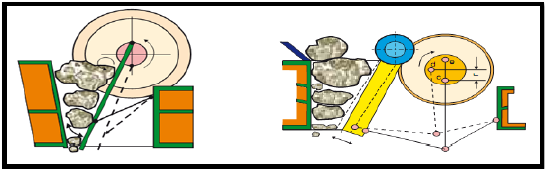

Rittinger’s Law: Rittinger stated that, “Energy expanded during comminution is proportional to the new surface area created as a result of particle fragmentation’’.

Mathematically, the statement can be represented as: E =K R(S2−S1)

1. Where, K R is called Rittinger’s constant or work index, and S2 & S1 are the final & initial specific surface areas respectively. In terms of particle diameter, it becomes
2. Mathematically

$$E= \frac{P}{M} =K_{R }\left(\frac{1}{D_{2}}\right. - \left.\frac{1}{D_{1}}\right)$$

**Where, P = power required for crushing**

**M= mass feed rate**

**D2= avg. product size**

**D1= avg. feed size**

**KR= Rittinger’s law constant**

**PROCEDURE:**

1. Sample out about 200 g of 20 mm gravel from a 6 kg gravel lot. Do the sieve analysis. From the weight %, compute the arithmetic average size.
2. Weigh about 5 kg of 20 mm gravel feed.
3. Adjust the jaws to have approximately 5 mm opening.
4. Avoid overfeeding or underfeeding the crusher. Do one preliminary experiments to find out the optimum feeding rate.
5. Note the initial reading of the energy meter.
6. At a uniform rate feed the gravel to the crusher. Note the time taken for crushing and reading of the energy meter at the end of the crushing (**E1**).
7. Run the crusher idle for the same time and note the reading (**E0**).

The Energy consumed for this crushing operation is

**Ex1 = E1 - E0**

1. Repeat the above test with a fresh feed of 2 kg with the jaws set at a 10 mm opening. Calculate **E2x = E2 - E0.**
2. Sample the products from the crusher. Do the sieve analysis, taking about 200g. From the wt. % compute the arithmetic average size (mean diameter).

**TABULATION**

|  |  |  |  |  |  |  |  |
| --- | --- | --- | --- | --- | --- | --- | --- |
| **Sl. No.** | **Sieve No** | **Sieve opening** | **Average Particle size Dpi** | **Mass retained** | **Mass function** | **Cumulative Mass function** | **Reciprocal of Avg. Particle sixe** |
|  |  |  |  |  |  |  |  |
|  |  |  |  |  |  |  |  |

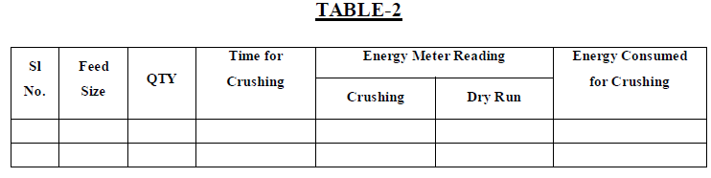

**GRAPH**

A graph between reciprocal of avg. particle size (1/Dpi) Vs cumulative mass fraction is plotted.

**CALCULATION**

The area under the avg. particle size (1/Dpi) Vs cumulative mass fraction graph is calculated, and the reciprocal of that area gives the avg. product size.

**Determination of grinding characteristics of a given mineral sample using Ball Mill.**

**AIM:**

To study the grinding characteristic like the effect of the following variables on grinding in a ball mill – (i) pulp density, (ii) Percentage of critical speed, and (iii) time of grinding.

**EQUIPMENT AND MATERIALS REQUIRED:**

1. Laboratory ball mill.
2. Balls( 1 ½”)
3. About 5 kg of any mineral (quartz, calcite or magnetite)
4. A set of sieves and a sieve shaker

**THEORY**

Ball mill is a tumbling mill, wherein size reduction occurs as a result of impact of the balls and by attrition. The ball mill consists of a cylindrical shell rotating about it axis. Cylindrical mills are classified according to the mode of product discharge taking place from the mill.

Different parts of ball mills are:

1. Cylindrical shell

2. Inner surface or liner

3. Grinding media

4. drive

**Cylindrical Shell:**

It is the rotating hollow cylinder partially filled with the balls. The ore to be crushed is fed through the hollow trunion at one end & the product is discharged through a similar trunion at the other end. The material of construction for this hollow shell is usually high strength steel. The shell axis is either horizontal or at a small angle to the base. Large ball mills have a length of 4 - 4.25 m, diameter of 3m. They use hardened steel balls of size varying between 25-125 mm.

**Inner Surface or Liners**

As the grinding process involves impact and attrition the interior of the ball mills is lined with replaceable wear resisting liners. The liners are usually high manganese alloy steels, stones or rubber. Least wear takes place on rubber lined interior. As the coefficient of friction between balls and steel liner is specifically, large, the balls are carried up taken to a higher height along the inner wall of the shell and dropped down onto the ore with a larger impact force resulting in a better grinding.

**Balls (Grinding Media)**

The balls are usually cast steel unless otherwise stated. In some cases, flint balls may be used. The diameter of the grinding media varies from 2.54 to 125 mm. The optimum size of the ball is proportional to the square root of the feed size. The ball and liner wear are usually in the range of 450 – 1250, and 0.50 – 250 g per ton of ore ground.

**Drive:**

The mill is rotated by electric motors connected through reduction gear box - ring gear arrangement.



**Schematic Diagram of a Cylindrical Ball Mill**

**Ball Mill Operation**

Ball mills may be continuous or batch type in which grinding media and the ore to be ground are rotated around the axis of the mill. Due to the friction between the liners–balls & liners–ore lumps, both the ore and balls are carried up along the inner wall of the shell nearly to the top from where the grinding media fall down on the ore particles below creating a heavy impact on them. This usually happens at the toe of the ball mill.

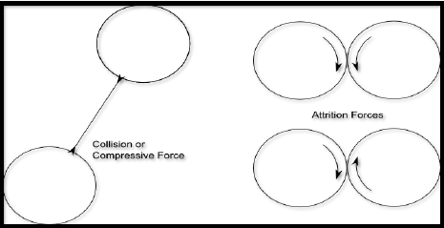

**Schematic Diagram of Different Type of forces during Ball Mill Operation**

The grinding process is attributed to 3 different stages of ball mill working.

i. Cascading ii. Cataracting iii. Centrifuging

If the speed of the ball mill is too low then only cascading occur, and particle lead to rolling down of the ball and limiting grinding will occur. On the other hand, if the speed of the ball is very high (greater than critical speed) centrifuging occur leading to little or no grinding. So the mill is to be operated between two extreme speed i. e below critical speed of the mill.

**Critical Speed of the Ball Mill:**

The minimum rotational speed at which centrifuging occurs in a ball mill is defined as its critical speed. It has already been noticed that no grinding takes place in the ball mill when it centrifuges. So the operating speed of the mill should always be less than its critical speed enabling the media to deliver impacts at the toe or knee of the mill to result in grinding.

Mathematically, critical speed is given by

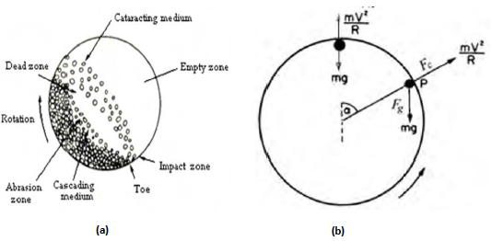 



The effective speed of the ball mill should be 65-80% of the theoretical critical speed. The lower value is for wet grinding while the higher value is opted for dry grinding.

**PROCEDURE:**

|  |  |  |  |
| --- | --- | --- | --- |
| **Test No** | **Time of grind (min)** | **% Solids in pulp** | **Speed % of critical** |
| 1 | 10 | 25 | 80 |
| 2 | 10 | 35 | 80 |
| 3 | 10 | 45 | 80 |
| 4 | 10 | 60 | 80 |
| 5 | 10 | 75 | 80 |

1. Half fill the mill with balls (1 ½”). Feed the charge to the mill. Add enough water to get the desired pulp density.
2. Run the mill at the required speed for the desired time.
3. At the end of the run, remove the pulp and ball charge.
4. Wash the pulp free from the balls. Filter, dry and weigh the sample.
5. Wash the pump free from the balls. Filter, dry and weigh the sample. Use of a D. C. motor and a D. C. power supply will facilitate changing the r.p.m of the mill. If it is not available, conventional A.C motor with different pulleys can be used to get different speeds.
6. Record the % wt. of -100 mesh, -150 mesh and – 200 mesh for all the experiments.
7. Plot the graphs of ‘Amount of -100 mesh produced (g/min) Vs pulp density’, ‘Amount of -100 mesh produced (g/min) Vs Mill Speed in % critical’, ‘Cum. %wt. of +48, +100, +200 and -200 mesh Vs time of grinding in minutes’ and discuss the results indicating effect of changing the pulp density, speed of mill and time of grinding.

**TABULATION**

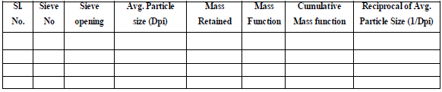

**GRAPH**

* Plot a graph between reciprocal of avg. particle size (1/Dpi) vs cumulative mass fraction is plotted.
* Plot a graph between % fines vs time of grinding.
* Plot a graph between % fines vs speed of rotation of grinding.

**CALCULATION**

The area under the avg. particle size (1/Dpi) Vs cumulative mass fraction graph is calculated, and the reciprocal of that area gives the avg. product size.

The graph between reciprocal of avg. feed size (1/Dpi) Vs cumulative mass fraction, and avg. product size was plotted, and it can be seen that fineness increases with increase in crushing time.

Similarly, when graph between reciprocal of avg. feed size (1/Dpi) vs cumulative mass fraction, plotted and avg. product size was calculated mechanically, and it can be seen that fineness increases with increase in speed of rotation up to critical speed, and above critical speed there is grinding does not takes place.

**Sieve analysis of a given sample and to calculate (a) percentage of sample retained on screen (b) to plot sizing curves (c) find d80 size.**

**AIM**: To determine and analyze the size distribution of a fixed granular solid by using a vibratory sieve shaker.

**EQUIPMENT AND MATERIALS REQUIRED:**

1. Sand / rock granular solid particles 2. Different sieves.

3. Weight balance (least count 0.01g) 4. Ro-Tap sieve shaker

**THEORY**

Sieve analysis is a technique which is used for particles distribution on the basis of its size and shape. There are 2 types of sieves used in general

1. US Standard ASTM E-11-01

2. British Standard Sieves BSS 410 -2000

In the Indian standard (IS) sieves, the mesh number is equal to tits aperture size expressed to the nearest deca-micron (0.01mm)

Mesh number

Mesh number is the number of openings per linear inch. Mesh number is inversely proportional to aperture size, thickness of wire

Size of the screen

It is the distance between two consecutive parallel wires.

|  |  |
| --- | --- |
|  |  |

Illustration of square openings

Sieve Shaker



**Illustration of a Ro-Tap Sieve Shaker**

Many natural and manufactured products or materials occurred in a dispersed form, they may consist of different shape and size of particles. The particles size distribution is responsible for physical, chemical, and mechanical properties.

**Sieve Analysis:**

Particle size can be determined by Mechanical sieving using sieve shaker.

Throw Action is a 3-D movement of powder sample which is used to determine the percentage of oversized and undersized particles. The amplitude of throw action varies 0 – 2 mm or 0 -3 mm.

**Mass Fraction:**

It is defined as the ratio of mass retained to the total mass taken. The cumulative mass fraction is the sum of all the previous mass fraction values.

**PROCEDURE**

1. First of all 500 g of dry sample is taken through a weight balance and is fed into a Ro-Tap sieve shaker, which has 7 nos. of sieves with mesh no. 8, 16, 22, 72, 85,100 and 150.

3. The sieves are arranged in ascending order so that 16 mesh no. is placed at the top and mesh no. 150 at the bottom.

5. Make sure that the sieves are clean, if many soil particles are struck in the openings, clean them.

4. At the bottom most, the pan is placed.

5. The machine is started by switching on the knob at bottom and the timer is fixed at 15 min.

6. After the completion of 15 min, the machine is automatically switched off.

7. The residue on different sieves are collected and weighted.

**TABULATION**

|  |  |  |  |  |  |  |  |  |
| --- | --- | --- | --- | --- | --- | --- | --- | --- |
| Sl | Sieve No | Mesh size in Microns | Mean size (µ microns) | Mass Retained  - R (g) | % (R) | ∑R (g) | % ∑R | % Pass  100-∑R |
| 1 | +12 | 1410 |  |  |  |  |  |  |
| 2 | -12+14 | 1190 | 1300 |  |  |  |  |  |
| … | -14+20 | 840 | 1015 |  |  |  |  |  |
| … |  |  |  |  |  |  |  |  |
| N |  |  |  |  |  |  |  |  |

|  |  |  |  |  |  |  |  |
| --- | --- | --- | --- | --- | --- | --- | --- |
|  |  |  |  |  |  |  |  |

**Interpretation and Reporting the Results**

There are many different ways of recording the results, the most common being that of plotting cumulative undersize (or oversize) against particle size. Although arithmetic graph paper can be used, it suffers from the disadvantage that points in the region of the finer aperture sizes tend to become congested. A semi-logarithmic plot avoids this, with a linear ordinate for percentage oversize or undersize and a **logarithmic abscissa** for particle size.

|  |  |
| --- | --- |
|  |  |

1. Draw a graph of log sieve size Vs % cum weight of material retained.

2. Draw a graph of log sieve size Vs % cum weight of (fines) material passed.

3. 80%Passing Size (d80) - is the size at which 80% of the particles pass through. This can be determined from the plot of cumulative weight percent passing versus sieve size. This size is used in determining energy requirements for reducing size of particles by comminution equipment.

**Concentration of a given mineral sample using mineral jig.**

**AIM**: To understand the principle of jigging and to separate the heavies from the given feed using the mineral jig.

**EQUIPMENT AND MATERIALS REQUIRED**: (i) A laboratory model mineral Jig (ii) An artificial mixture of coal and sand gravels (or) magnetite in the proportion of (heavy mineral **:** light mineral) = 1:4 (or) 1:8. Size range of feed: - 4 + 8 mesh and – 8 + 20 mesh.

**THEORY**

Jig is an open tank filled with water that has screen at the top and spigot or hutch compartment at the bottom. Jig bed may have heavy coarse material (ragging material)

Different parts of a Jig. 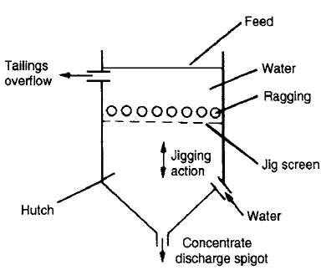

**DIFFERENT CONDITIONS IN JIGGING ACTION:**

1) Terminal Velocity - Initially particles have acceleration and increasing velocity. When equilibrium is achieved, particles reach their terminal velocity and they settle down at constant rate.

2. Hindered settling - When the slurry is subjected to several pulses before it exits the tailings weir of the jig, better separation will occur. After repeated pulses, particles become stratified, with heavy materials at the bottom and light particles at the top. The effect of particle crowding becomes more apparent and falling rate of particles begins to decrease. The other action, is the effect of the upward flow of water, it separates particles by their specific gravity. The system begins to behave as a heavy liquid whose density is that of the pulp rather than that of the carrier liquid.

**MECHANISMS**

1) Differential Initial Acceleration: The initial acceleration is dependent only on the densities of the solid and the fluid. It is necessary that short jigging cycle to separate small heavy particles to light particles.

2) Consolidation Trickling: In consolidation stage, where the large particles in the bed come close to each other leaving relatively large interstices filled with draining water running down as a result of the suction part of the strike.

Separation may be achieved over the screen or trough the screen in jigging.

**OPERATIONAL PARAMETERS**

1) Dilution: It is the amount of water. High dilution is necessary to remove large quantity of materials.

2) Screen Aperture: It must be as large as possible, consistent with feed size to minimize resistance to flow.

3) Stroke and Frequency: Stroke is moving distance of the piston and it depends on particle size. Frequency is the number of stroke per time.

4) Feed Rate and Particle Size Range: Jigs have high unit capacity and can achieve good recovery in particle size under 150 pm.

**PREOCEDURE**:

1. Fix the 6 mm screen and feed the synthetic mixture (- 4 + 8) by hand into the feeding compartment. Judge the correct feed rate by the preliminary experiment.
2. Observe the separation of the gauge mineral at the overflow lip and the formation of heavies in the jig compartment and also the heavies going into the glass hutch compartment as the hutch product.
3. Continue the feeding until the jig compartment is full with the heavies and the heavies start overflowing. Stop the feeding at this moment.
4. Collect separately the concentrate, the tails and the hutch product.
5. Prepare a graph of specific gravity versus coal-sand gravel composition (0 - 100%). If the other mixtures are used, prepare the graph accordingly.
6. Find out the specific gravities of the various products.
7. With the help of the graph, determine the amount of the heavies and the lights in the concentrate, in the tailings (*overflow*) and in the hutch product.
8. Repeat the experiment by replacing the 6 mm screen with 4 mesh screen and repeat the experiment using – 8 + 20 mesh feed.

**Concentration of a given mineral using Wilfley Table**

**AIM**: To study the motion of a wet concentrating table and to study the effect of different variable like feed rate, feed composition, sized and un-size feed on table.

**EQUIPEMENT AND MATERIALS REQUIRED**: (i) A laboratory size wet concentrating table (Wilfley) with variable speed drive (ii) Proper launders and containers for collecting the products (iii) About 2 - 3 kg of coal and fine sand gravel (or)quartz and magnetite.

**THEORY:**

* Tabling takes place on the Shaking or Wilfley table. The Shaking or Wilfley table essentially consist of a substantially plane surface called the deck. The table is slightly inclined to the horizontal from the left to right and shaken with an asymmetrical motion in the direction of the long axis. Asymmetrical motion makes the stroke of the table faster in one of the directions and slower in reverse.
* Usually a slow forward with a rapid return is used during the operation of the Wilfley table. This causes the mineral particles to crawl along the longitudinal cleats or riffles that are fixed on the table surface in the direction of the table movement. The wash water flows over the table at right-angles to the direction of jog. A feed of 25% solids by weight is introduced through the feed box at the upper corner of the table, and as the feed particles hit the deck they are fanned out by a combination of differential motion, and transversely flowing water.
* The jolt during the return stroke causes the heavier particles to work-down the bed to form the bottom layer. The lighter gangue materials are thrown into suspension, and are discharged out over the edge of the table opposite to the feed box by the wash water.
* The heavier minerals finally arrange themselves on the smooth un-riffled proportion of the table when they encounter the full force of the wash water. The middlings are collected in that portion of the table intermediate between concentrate & tailings. A finer feed requires a higher reciprocating speed but a smaller stroke length while a coarser feed requires larger stroke length with reduced reciprocating speed. Hence the stroke length along with the reciprocating speed of the table can be adjusted as per the feed material to be classified on the table.

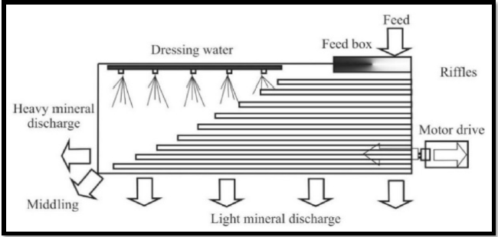

Schematic Diagram of Wilfley Table

**PROCEDURE:**

1. Prepare a synthetic mixture of coal and fine sand gravel (or) quartz and magnetite. Keep the ratio of heavy mineral :light mineral as equal to 1:4 and prepare about 2 - 3 kg of the feed.
2. Open up the head motion box and study the movement of the eccentric shaft, toggles, cam and pitman by rotating the shaft manually.
3. Initially, take a sample of (-30 mesh) feed, manually feed a pulp (20 percent solids) of the feed at a slow rate of about 0.5 kg solids per minute, which is optimum for a laboratory size table. Vary the length of the stroke, the number of stokes per minute, the slope of the deck and the amount of wash water until you get a very satisfactory separation. Find out the optimum conditions and keep them constant in the subsequent experiments.
4. Now, take sample of (-30 mesh) above feed and feed to the table keeping the amount of wash water, slope of the deck, number of strokes and stroke length constant. Obtain products containing a clean lights and a mixed middling of heavies and lights.
5. Keeping all the other variable as in 4, change the feed rate to twice the earlier rate and repeat step 4.
6. Repeat step 4 with optimum conditions obtained in step 3 using different samples, if required.
7. At the end of each experiment collect the products. Filter, dry and weigh.
8. Draw the samples. Determine the composition of the different fractions using a weigh

**

**CALCULATION:**

The efficiency of the Tabling process gets calculated by using the following mathematical formula

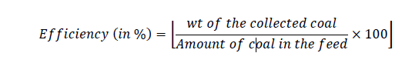

**Concentration of a given mineral using froth flotation cell**

**AIM**: To study the flotation characteristics o a sulphide ore.

**EQUIPMENT AND MATERIALS REQUIRED**: (i) A laboratory flotation cell (ii) Measuring cylinders, syringe, etc (iii) Trays to collect the froth (iv) 10 kg of chalcopyrite ore (sample) (v) Collectors – sodium /potassium ethyl (or) isopropyl (or) butyl (or) amyl xanthate (vi) Frothers – Pine oil (or) MIBC.

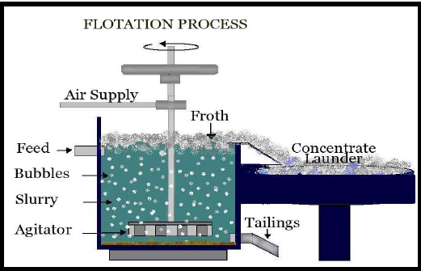**THEORY:**

Froth Flotation Process:

* Flotation is the most widely used method of wet concentration of ores for separating the valuable constituent of the ore from the worthless gangue. The process is primarily a surface phenomenon based on the adhesion of some mineral particles to air, and simultaneous adhesion of other particles to water in the pulp.
* Flotation process is the most efficient, but is the most complex of all ore beneficiation processes. In this process adhesion is made between air bubbles, and small mineral particles in such a way that they rise in that pulp. The floating mineralized froth is then skimmed off while the other minerals are retained in the pulp. This fact is well-known flotation proper.
* Floatation Cell Function of aeration element is based on step diffuser design. Acceleration in the aeration tube generates a vacuum, which sucks the necessary process air, which forms bubbles in the stock. Bubbles remove the particles from the stock suspension.
* Floatation Cell Dirt laden bubbles rise to the top of the cell, forming a foam layer. The foam layer gets skimmed off into the foam collecting chamber.
* Froth flotation is employed widely in metallurgical industries and coal.
* In the pneumatic flotation cells compressed air is directly blown into the pulp while in the sub-aeration cell a rotating impeller serves as a pump, which draws in air through the hollow shaft of the impeller and distributes the same into the pulp to produce the froth. In the laboratory, usually a rotating, hollow impeller type sub-aeration cell is used.

**Procedure**:

1. Crush the given chalcopyrite ore or any other sample to all passing – 10 mesh in stages.
2. Mix the crushed sample well and riffle out 1 kg lots (or any other suitable weight) in bags.
3. Fill the flotation cell with water to approximately 2.5 cm below the top level.
4. With the help of a measuring cylinder find out the volume of water.
5. Knowing the volume of the cell from the above test take the correct weight of the feed to give a pulp density of about 30% solids.
6. Grind the crushed ore to say 60-65% -200 mesh in a laboratory ball mill, depending on the availability of sufficient time.
7. Transfer the pulp to the cell now.
8. Switch on the flotation machine and keep the pulp in agitation with the air cock closed. If possible adjust the r.p.m to 1500. Do not change the speed during the flotation test.
9. Add lime and check the pH of the pulp. Add more lime till the pH is in the range of 9 – 9.5.
10. With the air off, add xanthate (0.05 kg/tonne of ore; i.e. 10 ml of 0.25 percent solution of xanthate for 0.5 kg of feed sample). Condition for two minutes.
11. Add 4 drops (say 30-40 mg) of the frother from a calibrated syringe and condition for one minute.
12. Open the air cock and start collecting the froth. Collect the first concentrate for the first 2 minutes. Close the air cock.
13. Wash back into the pulp any froth adhering to the sides of the cell with a wash bottle. Ass some more make-up water, if needed, to keep the pulp level about 2.5 cm below the lip level.
14. Add another installment of the collector and the frother and proceed as above.
15. Collect the next concentrate for 2 more minutes in another container.
16. Filter the two concentrates and tails separately and dry the samples, weigh it.

$$Separation Efficiency \left(in \%\right)= \frac{W_{1}}{W_{2}} X100$$

**Study of washability characteristic of a coal sample using float and sink test.**

**AIM**

To Conduct float and sink test to determine the quantity fractions at each specific gravity and draw graphs.

**EQUIPMENT AND MATERIALS REQUIRED**:

1. Beakers.
2. Solvents. (i) Tetrabromoethane (TBE) with a relative density of 2.96.

(ii) Perchloroethylene with relative density of l.6.

(iii) White spirit with a relative density of O.77.

(iv) Petroleum spirit with a relative density of 0.7.

**THEORY**

1. **Float and Sink Tests** Float and sink tests are essentially a gravity-based separation using liquids having densities between the lower and higher density components of the coal to be separated.

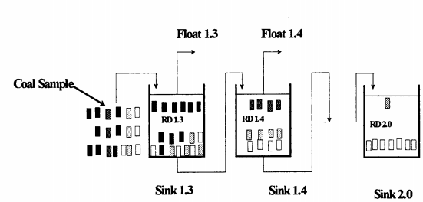

A typical series of liquid relative densities used in float and sink testing is RD 1.30, 1.35, 1.40, 1.45, 1.50, 1.60, I. 70, 1.80, 1.90 and 2.00 by mixing different liquids at suitable proportions.

**PROCEDURE**

1. The method involves accurate sub-division of the coal sample so that a number of identical samples are each subjected to a liquid of one particular density.
2. If sample is to be analyzed for 10 different specific gravities, 10 equal parts of the representative sample and the heavy liquids having specific gravities in the desired range should be prepared.
3. Each part is introduced into one of the heavy liquids. After the separation has taken place, the float and sink products are obtained from each of the heavy liquids.

**The parallel float sink method has advantage over serial float sink method;**

1. The individual mass fraction in each specific gravity interval can be calculated if required, but it is normal practice to use the cumulative values for washability.
2. In this method the size of individual representative sub-samples can be kept relatively small, leading to a better separation due to less particle-particle interaction.
3. This method is fast because each sample is treated separately. It avoids the delay caused by the need to drain a sink material before proceeding to the next heavy liquid.
4. Another important advantage of parallel float and sink test is the ability of easily checking the test at any time.
5. In this method the bulk specific gravity of each sub-sample remains constant and equal to that of the main sample because no material is transferred to the next liquid of different specific gravity.

**Other Aspects**

1. Normally Tetra-bromo-ethane (TBE) which is very toxic.
2. Float and sink tests also cause a breakage of particles during handling and repeatedly washing float and sink materials, the resultant liberation of mineral matter altering the washability of the coal.
3. The float and sink test is a very tedious and time consuming procedure. A complete set of tests for particles of size less than half of a millimeter needs up to 10 days if high accuracy results are required. Moreover for a comprehensive test, a large amount of sample is necessary.
4. The sources of errors in float and sink tests are considerable and an error at any one stage of the serial float and sink test affects the results of the subsequent stages.

|  |  |  |  |  |  |  |
| --- | --- | --- | --- | --- | --- | --- |
| Specific gravity of liquid used | Weight of coal floated  (g) | Weight of coal taken for ash determination | Weight of Ash (g) | Ash% in floated coal | Wt% of floated coal | Cum Weight% of floated coal |
| 1.30 |  |  |  |  |  |  |
| 1.35 |  |  |  |  |  |  |
| 1.40 |  |  |  |  |  |  |
| 1.45 |  |  |  |  |  |  |
| 1.50 |  |  |  |  |  |  |
| 1.55 |  |  |  |  |  |  |
| 1.60 |  |  |  |  |  |  |
| 1.75 |  |  |  |  |  |  |
| 2.00 |  |  |  |  |  |  |
| 2.00 (sink) |  |  |  |  |  | 100% |
|  |  |  |  |  | 100 |  |

Drawing the curves

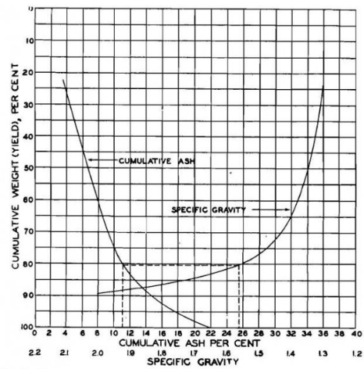

Observations:

1. Production of a washed coal of a certain ash content% depends on how the various constituents with respect to specific gravity are in the feed to washer..
2. Prepare a specific-gravity curve and cumulative-ash curve of the feed.
3. The specific gravity of separation is decided based on the ash percentage desired in the washed coal. Ex. Steel grade coking coal of 11% ash.
4. from X-axis of Cumulative ash% of 11%, meet the Characteristic curve. From that point, move to meet cumulative yield gravity curve and from there, determine specific gravity value on X axis for sg-sink/float separation i.e., 1.56.
5. From that sg, if we consider the ±0.10 range sg, the percentage by weight of the total feed within this range determines how difficult the separation will be because of the tendency of washed coal and refuse to overlap.

**Study of Sedimentation characteristics.**

**AIM:**

To conduct sedimentation test and study its characteristics and the rate of sedimentation.

**Materials Required**

|  |  |
| --- | --- |
| 1. Vernier caliper 2. 1000-mL graduated cylinder 3. Stirring rod 4. Aluminum foil 5. 500 ml Beaker 6. PPE (e.g. mask, glove) | 1. Baking soda sample 2. Distilled water 3. Stopwatch 4. Ruler 5. Analytical balance |

**THEORY**

Dewatering is important operation in mineral processing. The purpose of dewatering is to remove water absorbed by the particles which increases the pulp density. This is done for a number of reasons, specifically, to enable ore handling and concentrates to be transported easily, store until processing to allow further processing to occur and to dispose of the gangue. The water extracted from the ore by dewatering is re-circulated for plant operations after being sent to a water treatment plant. The main processes that are used in dewatering include dewatering screens, sedimentation, filtering, and thermal drying. These processes increase in difficulty and cost as the particle size decreases.

Dewatering screens operate by passing particles over a screen. The particles pass over the screen while the water passes through the apertures in the screen. This process is only viable for coarse ores that have a close size distribution as the apertures can allow small particles to pass through.

Sedimentation operates by passing water into a large thickener or clarifier. In these devices, the particles settle out of the slurry under the effects of gravity, or centripetal forces. These are limited by the surface chemistry of the particles and the size of the particles. To aid in the sedimentation process, flocculants and coagulants are added to reduce the repulsive forces between the particles. This repulsive force is due to the double layer formed on the surface of the particles. The flocculants work by binding multiple particles together while the coagulants work by reducing the thickness of the charged layer on the outside of the particle. After thickening, slurry is often stored in ponds or impoundments. Alternatively, it can be pumped into a [belt press](https://en.wikipedia.org/wiki/Belt_press) or membrane [filter press](https://en.wikipedia.org/wiki/Filter_press) to recycle process water and create stackable, dry filter cake, or "tailings".

Thermal drying is usually used for fine particles and to remove low water content in the particles. Some common processes include rotary dryers, fluidized beds, spray driers, hearth dryers and rotary tray dryers. This process is usually expensive to operate due to the fuel requirement of the dryers.

**Sedimentation**

Sedimentation is water treatment process, during which water has little or no movement, and suspended solids sink to the bottom under the force of gravity and form sediment. This process is called sedimentation

This phenomenon of settling down of particles at the bottom of sedimentation tank is known as hydraulic subsidence and every particle has its own hydraulic settling value which will cause its hydraulic subsidence

The particles having specific gravity of about 1.2 or so readily settle down at the bottom of tank. But it is difficult to cause the settlement of lighter particles. Suspended solids present in water having specific gravity greater than that of water tend to settle down by gravity as soon as the turbulence is retarded by offering storage. Inorganic suspended solids have specific gravity of about 2.65; and Organic suspended solids about 1.04

**Plain sedimentation**: It is process of settling down of solids and impurities in the raw water to the bottom of sedimentation basin by natural gravity force alone, no chemical is added.

**Sedimentation by using clarifier and contact**: In this method chemicals are mixed in water and that water is rotated by help of pumps for period of two hours per day, and suspended solids are settled down in the bottom of reservoir or tank, etc.

Water generally flows through a tank as an irregular flow thus the intention of sedimentation is to create condition in which the flow is uniform for long enough period to permit the maximum practical amount of floc to be settled before the water reaches at the end of tank. In general most used process is chemically assisted horizontal sedimentation and following assumptions are based on.

In continuous type tank, the flow velocity is only reduced and water is not brought to complete rest.

The intermittent type tanks are those which store water for a certain period and kept on complete rest.

$$t= \frac{Volume}{Flow rate }= \frac{V}{Q}= \frac{L X B X D}{A X V}$$

Where, t is detention time in seconds, **Q** is the flow rate in m3/sec, **L, B, D** in meters

Detention time is inversely proportional to the incoming flow rate - as flow rate increases, the detention time decreases.

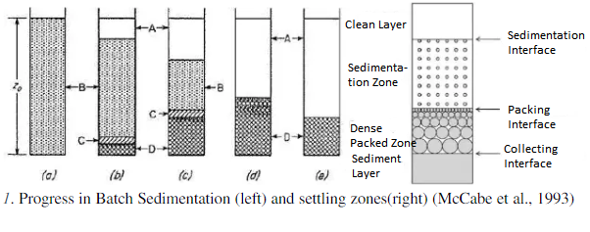

Zone A is called the clear layer where particle concentration is almost zero.

Zone B is called the sedimentation zone and the concentration is uniform and equal to the original suspension.

The interface at which zone A and B coincides is called the sedimentation interface.

Zone C is called transition layer or a densely-packed zone.

The settled solids are located in Zone D (sediment layer)

As the sedimentation process continues, the depths of zones A and D increase (Figures 1bto e) while the depth of zone B decreases. The depth of zone C almost remains constant (Figures1b to c). Eventually, zone B disappears and the solids are deposited at zone D and C deposited at zone D and C.

The settling of particles is generally affected by the container size and its interaction with other particles. If its distance from the wall is sufficient enough or if the ratio of the particle diameter to the diameter of the container is less than 1:200 or if the particle concentration is less than 0.2 volume percent, the interference will be less than 1%. In this case the particle is said to be free settling, otherwise the term hindered settling is applied since the particles become too crowded and settling rate proceeds at a lower rate (Geankoplis, 2003).

The reasons for modification of the settling rate of particles in a concentrated suspension include: (a) when a wide range of particle sizes are present in the feed, differential settling rates between large and small particles lead to modification of the effective density of the suspension, (b) the upward velocity of the fluid is greater at higher concentrations, (c) the velocity gradients in the fluid surrounding the particles are greater due to the closer proximity of the particles and (d) the ability of particles to aggregate is enhanced at higher concentrations (Latsa et al., 2005). Other less apparent factors affect the sedimentation rate arise from the particle size, density and concentration, and fluid viscosity. These include particle shape and orientation, convection currents in the surrounding fluid, and chemical pretreatment of the feed suspension (Foust et al., 2008). Sedimentation of a suspension is generally assessed by a jar test, usually using a graduated cylinder, during which a suspension is allowed to settle and the height of the clear liquid -suspension interface is measured as a function of the settling time. The expected raw data to be gathered are height of interface zones in terms of volume markings and the corresponding time. The cross-sectional area of the graduated cylinder will be determined by measuring its inside diameter. To obtain the actual interface height, the recorded volumes are divided by the cross-sectional area of the cylinder. Figure 2 below shows how the interface height can be determined in a jar or cylinder test.

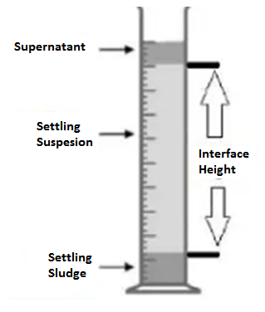

$$Z= \frac{Volume Level}{Cylider Area} (I)$$

Zones of settling after a given time and determination of the interface height (Tarleton& Wakeman, 2007

The recorded volume markings are divided by the cross-sectional area of the cylinder to obtain the actual interface height (z) (Tarleton & Wakeman, 2007)

The interface height (z) is plotted against time. It can be observed that the slope of the plot, which is the velocity of settling, is constant before reaching the critical point C. With the limitations to the number of data which can be gathered, the velocity can be estimated by finding the slopes between adjacent points using equation below (Geankoplis, 2003)

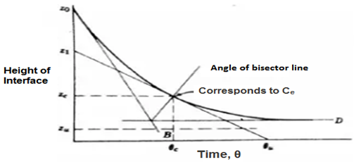

**Corresponds to Ce Time, θ**

Height of Interface vs Time curve (Foust, 1980)

The settling rate or settling velocity can be obtained from the plot shown above. The instantaneous settling velocity is the slope of the line tangent to the curve -dz/dt = v or given by the equation:

$$V_{i}= \frac{Z_{i}- Z_{i+1}}{t_{i+1}- t_{i}}$$

Where, v is the settling rate and z is the interface heights with respect to time interval t.

One of the simplest methods to determine the critical point of a settling curve is to draw two tangent lines, one in the free settling portion and other at the final compression at the near end of settling in which interface height becomes almost constant as seen in Graph. In the same figure, an angle bisector of the two tangent lines, which vertex is the intersection point, is drawn. The intersection of the angle bisector and the settling curve is an estimate of the critical point (Foust et al., 1980).

This experiment aimed to determine the effect of varying slurry concentration to the sedimentation process. Specifically, it aimed to:

**a.** Determine the relationship between time and interface height at different slurry concentrations; and

**b.** Determine the relationship between time and settling rate at different the slurry concentrations

**Procedure**

* The Material Safety Data Sheet of flour was reviewed.
* The inner diameter of the 1000-ml graduated cylinder was measured using the Vernier caliper.
* Three samples of 20 g, 40 g, and 60 g of flour were weighed on a 500-mLbeaker. A significant amount of distilled water was poured into the 500-mL beaker and was slowly mixed with the previously weighed 20 g of flour using stirring rod.
* Subsequently, the mixed solution was poured into the 1-litre graduated cylinder and was diluted into the1000 ml mark.
* The contents were then stirred again using stirring rod for 30 seconds to ensure uniform particle concentration distribution. After stirring, the height of the mixture was recorded. The mixture was allowed to settle and the volume reading of the interface height was then noted for every 2 minutes interval.
* The particles were found to fully settle the next day of the experiment. The same steps were repeated for the two other concentrations namely 40 g/*l* and 60 g/*l*

**Noting of observations:**

|  |  |  |  |  |  |  |  |
| --- | --- | --- | --- | --- | --- | --- | --- |
| **Time Interval**  **(mins)** | **Volume Readings (mL)** | | |  | | | |
| **20g/L** | **40g/L** | **60g/L** |  |  |  | |
| 0 |  |  |  |  |  |  | |
| 2 |  |  |  |  |  |  | |
| 4 |  |  |  |  |  |  | |
|  | | | |  |  |  | |
| 30 |  |  |  |  |  |  | |
| 40 |  |  |  |  |  |  | |
|  | | | | | | |
| 120 |  |  |  |  |  |  | |
| 1170 |  |  |  |  |  |  | |

**Conclusion:**

The concentration of the solid greatly affects the settling of solids particles in suspension in water or any fluid. The interface height decreases slower in higher solids concentration (40 and60 g/ml) than for the lower solids concentration (20 g/ml). The settling rate of solid particles decreases as time progresses and as the interface height decreases due to the crowding of solid particles, thus, causing hindered settling.

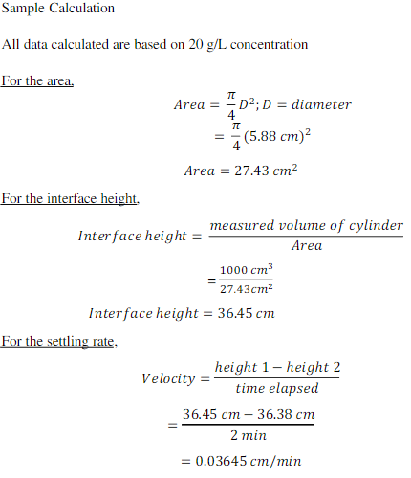

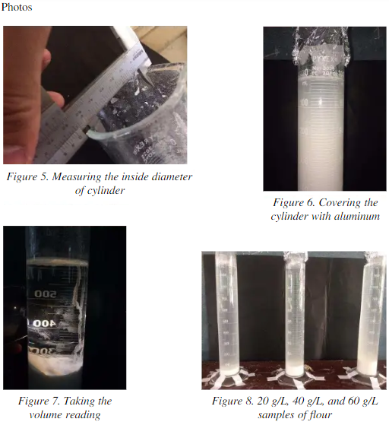

**Estimation of moisture content by drying of mineral.**

**OBJECTIVE**Determine the natural content of moisture in the given soil sample.

**NEED AND SCOPE OF THE EXPERIMENT**

In almost all soil tests natural moisture content of the soil is to be determined. The knowledge of the natural moisture content is essential in all studies of soil mechanics. To sight a few, natural moisture content is used in determining the bearing capacity and settlement. The natural moisture content will give an idea of the state of soil in the field.

**DEFINITION**

The natural water content also called the natural moisture content is the ratio of the weight of water to the weight of the solids in a given mass of soil. This ratio is usually expressed as percentage.

**APPARATUS REQUIRED**

|  |  |
| --- | --- |
| 1. Non-corrodible air-tight container. | 2. Electric oven, maintain the temperature between 1050 C to 1100 C. |
| 3. Desiccator | 4. Balance of sufficient sensitivity. |

**PROCEDURE**

1. Clean the container with lid, dry it and weigh it (W1).
2. Take a specimen of the sample in the container and weigh with lid (W2).
3. Keep the container in the oven with lid removed. Dry the specimen to constant weight maintaining the temperature between 1050C to 1100C for a period varying with the type of soil but usually 16 to 24 hours.
4. Record the final constant weight (W3) of the container with dried soil sample. Repeat and other organic soils are to be dried at lower temperature (say 600C) possibly for a longer period.
5. Certain soils contain gypsum which on heating loses its water if crystallization. If it is suspected that gypsum is present in the soil sample used for moisture content determination, it shall be dried at not more than 800 C and possibly for a longer time.

**OBSERVATIONS AND RECORDING**

Data and observation sheet for water content determination

|  |  |  |  |  |
| --- | --- | --- | --- | --- |
| **S.No.** | **Sample No.** | **1** | **2** | **3** |
| 1 | Weight of container with lid W1 g |  |  |  |
| 2 | Weight of container with lid +wet soil W2 g |  |  |  |
| 3 | Weight of container with lid +dry soil W3 g |  |  |  |
| 4 | Water/Moisture content  W = [(W2-W3)/(W3-W1)]X100 |  |  |  |

**INTERPRETATION AND REPORTING**

**RESULT**

The natural moisture content of the soil sample is ________

**GENERAL REMARKS**

1. A container without lid can be used, when moist sample is weighed immediately after placing the container and oven dried sample is weighed immediately after cooling in desiccators.

2. As dry soil absorbs moisture from wet soil, dried samples should be removed before placing wet samples in the oven.

**Determination of average size of sample.**

**Theory:**

Size of the particle is most important consideration in mineral and coal processing as the energy consumed for reducing particle size depends on size. Particle size determines the type of equipment employed for size reduction, beneficiation, handling etc.

The set of test sieves can be used and the sample materials can be sieved and the data is prepared on a table

**TABULATION**

|  |  |  |  |  |  |  |  |  |  |  |
| --- | --- | --- | --- | --- | --- | --- | --- | --- | --- | --- |
| **Sl** | **Sieve No**   |  |  | | --- | --- | | **-** | **+** | | **Mesh size in Microns** | **Mean size**  **(µ microns)** | **Mass Retained**  **- R (g)** | **% (R)** | **∑R (g)** | **% ∑R** | **% Pass**  **100-∑R** |
| 1 | +12 | 1410 |  |  |  |  |  |  |
| 2 | -12+14 | 1190 | 1300.0 |  |  |  |  |  |
| 3 | -14+20 | 840 | 1015.0 |  |  |  |  |  |
| 4 | -20+28 | 595 | 717.5 |  |  |  |  |  |
| 5 | -28+35 | 420 | 507.5 |  |  |  |  |  |
| 6 | -35+48 | 297 | 358.5 |  |  |  |  |  |
| 7 | -48+65 | 210 | 253.5 |  |  |  |  |  |
| 8 | -65+100 | 149 | 179.5 |  |  |  |  |  |
| 9 | -100+150 | 105 | 127.0 |  |  |  |  |  |
| 10 | -150+200 | 74 | 89.5 |  |  |  |  |  |
| 11 | -200 |  | 37.0 |  |  |  |  |  |
| Total weight of sample | | | |  |  | | | |

|  |  |  |  |  |  |  |  |
| --- | --- | --- | --- | --- | --- | --- | --- |
|  |  |  |  |  |  |  |  |

**Interpretation and Reporting the Results**

There are many different ways of recording the results, the most common being that of plotting cumulative undersize (or oversize) against particle size. Although arithmetic graph paper can be used, it suffers from the disadvantage that points in the region of the finer aperture sizes tend to become congested. A semi-logarithmic plot avoids this, with a linear ordinate for percentage oversize or undersize and a **logarithmic abscissa** for particle size.

|  |  |
| --- | --- |
|  |  |

The graphical format is referred to as particle-size distribution or gradation curve.

1. Draw a graph of log sieve size Vs % cum weight of material retained.

2. Draw a graph of log sieve size Vs % cum weight of (fines) material passed.

3. D50: The portions of particles with diameters smaller and larger than this value are 50%. Also known as the median diameter.

4. 80%Passing Size (d80) - is the size at which 80% (majority) of the particles pass through. This can be determined from the plot of cumulative weight percent passing versus sieve size. This size is used in determining energy requirements for reducing size of particles by comminution equipment.